To keep us all safe –

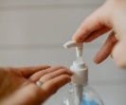
- We sanitise our hands each morning before we come into our classroom
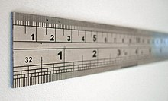
- We stay 1 metre apart from each other

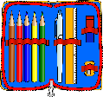
- We use our own stationery; pens, colours, rulers… and nobody else’s
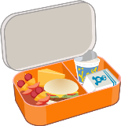
- We all wash our hands before we eat our lunch at break-times

- We sanitise our hands after each break before we come back into our classroom
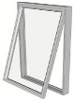
- We open the windows and doors for ventilation. Leaving the doors open means we are not all touching door handles.

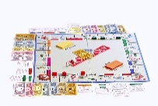
- If playing a game with a friend, we stay 1 metre apart and wash or sanitise our hands before and after the game

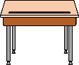
- We clear off our tables at 2:50pm each day and put everything into our baskets so our tables can be cleaned by teacher

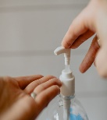
- We sanitise our hands before we leave the school at hometime

